Ideation Phase
Define the Problem Statements

Date | 20 February 2026
Team ID | LTVIP2026TMIDS82947
Project Name | ShopSmart
Maximum Marks | 2 Marks

Customer Problem Statement Template:
Example:
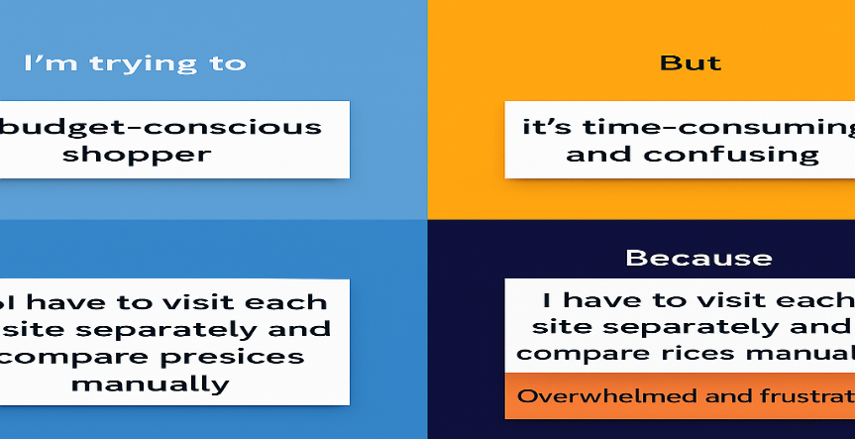

Problem Statement (PS) | I am (Customer) | I’m trying to | But | Because | Which makes me feel
PS-1 | a busy working individual | buy groceries conveniently from home | I still have to visit physical stores and stand in queues. | there’s no reliable local grocery delivery platform | frustrated and tired.
PS-2 |  | ensure items I need are in stock before ordering | store inventory is not updated in real-time | shopkeepers manage stock manually. | disappointed and uncertain
  a regular grocery buyer
PS-3 | a small grocery store owner | manage my inventory and orders digitally | everything is tracked on paper or Excel manually. | I don’t have access to a simple, digital solution | overwhelmed and inefficient
PS-4 | A digital-first user who prefers online apps | find a local grocery store that delivers quickly | most nearby stores don’t have an online presence | they haven't yet adopted digital commerce | forced to use big platforms or shop offline

